Project Design Phase- II Technology Stack (Architecture &Stack)

|  |  |
| --- | --- |
| **Project** | **Industry Specific Intelligent Fire Management System** |
| **Team ID** | **PNT2022TMID12796** |

# Technical Architecture:

The Deliverables hall include the architectural diagram as below and the informations per the table1&table2

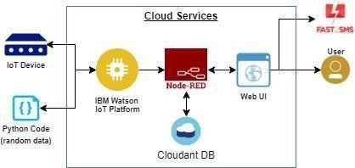

Guidelines:

1. Include all the processes(As an application logic/Technology Block)
2. Provide infrastructural demarcation(Local/Cloud)
3. Indicate external interfaces(third party API’ set c.)
4. Indicate Data Storage components/ services
5. Indicate interface to machine learning models(if applicable)

# Table-1: Components&Technologies:

|  |  |  |  |
| --- | --- | --- | --- |
| **S.No** | **Component** | **Description** | **Technology** |
| 1. | User Interface | Web UI ,Node-RED, MITapp | IBM IoT Platform, IBM Node red, IBM Cloud |
| 2. | ApplicationLogic-1 | Create Ibm Watson IoT platform and create node- red service | Ibm Watson ,ibm cloudant service, ibm node-red |
| 3. | ApplicationLogic-2 | Develop python script to publish and subscribe to IBM IoT Platform | python |
| 4. | ApplicationLogic-3 | Build a web application using node-red service | IBM Node-red |
| 5. | Database | Data Type, Configuration set c. | MySQL |
| 6. | Cloud Database | Database Service on Cloud | IBMDB2, IBM Cloudant |
| 7. | File Storage | Developing mobile application to store and receive the sensors information and to react accordingly | Web UI, python |
| 8. | ExternalAPI-1 | Using this IBM fire management API we can track  the temperature of the incident place and where the fire had been attacked. | IBM fire management API |
| 9. | ExternalAPI-2 | Using this IBM Sensors it detects the fire,  Gas leaks, temperature and provides the activation of sprinklers to web UI | IBM Sensors |
| 10. | MachineLearningModel | Using this we can derive the object recognition model | Object Recognition Model |
| 11. | Infrastructure(Server/Cloud) | Application Deployment on Local System / Cloud Cloud Server Configuration | IBM cloudant, IBM IoT Platform |

**Table-2:ApplicationCharacteristics:**

|  |  |  |  |
| --- | --- | --- | --- |
| **S.No** | **Characteristics** | **Description** | **Technology** |
| 1. | Open-Source Frameworks | MIT app Inventor | MIT License |
| 2. | Security Implementations | IBM Services | Encryptions, IBM Controls |
| 3. | Scalable Architecture | sensor-IoT Cloud based architecture | Cloud computing and AI |
| 4. | Availability | Mobile ,laptop, desktop | MIT app |
| 5. | Performance | Detects the Fire, gasleak, temperature | sensors |